Community assessment tool

General Conference Ministries
 |  | Leader’s Guide

course kit contents:
- Presenter’s guide
- PowerPoint slides
- Worksheet

materials needed
- Pens or pencils
- Paper
- Computer (for your presentation)
- Projector and screen
- Tables and chairs
- Sound system (for large classes)

Tips and Guidelines
1. |  |  | Come prepared.  Review the entire content and handout materials before the session. Arrive early for your presentation. Set up your equipment and test everything before the participants arrive.
2. |  |  | Greet the participants as they arrive.  One of our goals is to build relationships within the community. Greeting people as they enter puts them at ease and can open doors for further dialogue.
3. |  |  | Start on time.  The presentations are designed to be less than 1.5 hours. Honor that time frame.
4. |  |  | Welcome students and introduce yourself.  This introduction should take only 30 to 60 seconds.
5. |  |  | Introduce the topic of the presentation.  A brief introduction appears in the script under slide 2. Keep it short. Introductions should get the participants’ attention, not bore them.

6. |  | Give the PowerPoint presentation.  Study the script ahead of time so that your presentation flows smoothly.
7. |  | Introduce and distribute the quiz.  Detailed instructions are given in the script. Have the participants work in small groups of two to four, discussing and completing the quiz together. (If the nature of your group warrants it, lead the discussion of the quiz questions from the front, soliciting responses from the participants.) Give the participants about 20 minutes to complete the quiz. Monitor the participants’ progress, adjusting the time as needed to allow them time to complete the worksheet. Then call them back together as a group and discuss the answers using the answer key.
8. |  | Thank the participants for coming and visit with them as they are leaving.

WELCOME
 | Slide 1
If you are attending this seminar, it probably means you have an interest in entering a community for God (your own community or another). This is a huge challenge, but a God-designed one.
It’s always best to work with a team, so one of the first things to do is find likeminded people who share the same vision you do.
 | Personal assessment
 | Slide 2
Any assessment of the community should begin with an assessment of yourself.
This is important because you need to approach the community with the right spirit and the right motivation. Questions to prayerfully and honestly ask yourself are:
 | Motivation
 | Slide 3
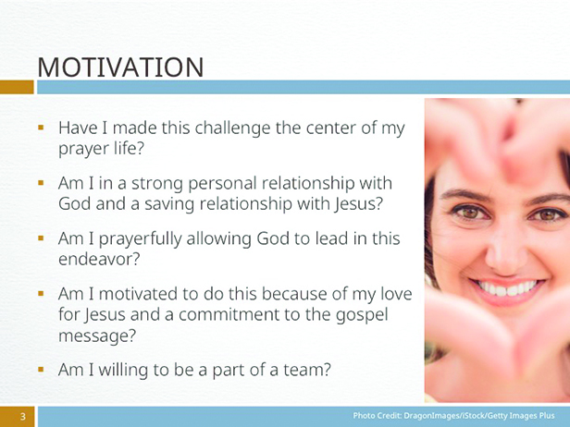 |  | - Have I made this challenge the center of my prayer life?  - Am I in a strong personal relationship with God and a saving relationship with Jesus? Am I dependent on God’s leading in my life?  - Am I prayerfully allowing God to lead in this endeavor?  - Am I motivated to do this because of my love for Jesus and a commitment to the gospel message? Or am I doing this for personal reasons?  Am I willing to be a part of a team, willing to come under the rule of the team’s “group wisdom?”
 | A RIGHT SPIRIT
 | Slide 4
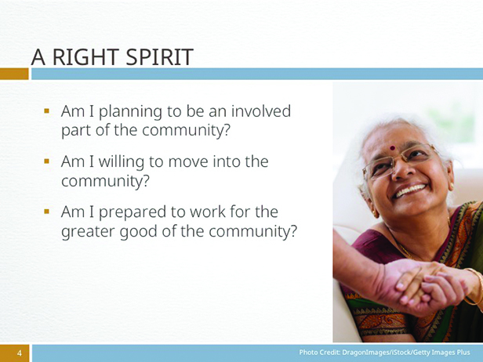 |  | Ask yourself: Am I planning to be an involved part of the community? Or do I want to be a “rescuer,” one who plans to “save” people from themselves? In other words, do I plan to be one with them, or are my neighbors a “project” that I want to complete? The right spirit is to be one with them.  If you live outside the community you want to impact, ask yourself: Am I willing to move into the community?” People become suspicious of those community assessment tool who come into their community, do good things, and then leave.  Am I prepared to work for the greater good of the community rather than for short-term personal gains?
 | Assessing the community
 | Slide 5
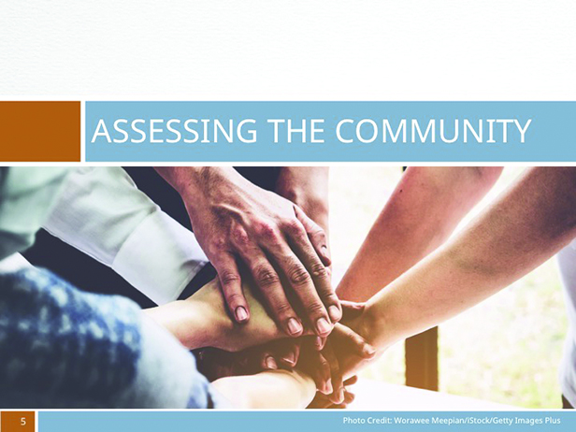 |  | Even if you live in the community you are assessing, it is surprising how little you may know about the people who live there. The following will help focus on the community and the people who live and work there.

 | START WITH A MAP
 | Slide 6
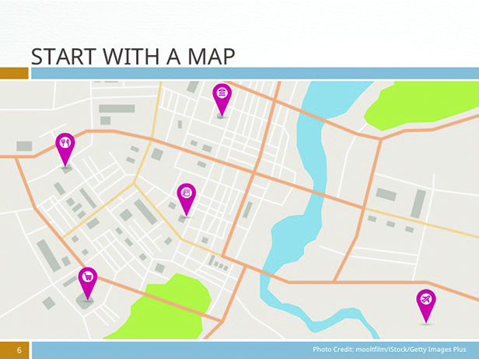 |  | Take the broad view of the city or region you plan to work in so that you can see where your community fits into the bigger region or nation of which it is a part. Work out the boundaries of your target community or area. Once your territory is defined, ask how the locals describe this region. This is an important step in collecting demographic information on your chosen area.
 | LOCAL MEDIA
 | Slide 7
Now check the local media. All forms of media are useful, but the print media may be most helpful at the beginning. The Internet is particularly helpful if you live some distance from the community you are planning to work in—you can get a feel of the area even before you begin your work there. Make note of local concerns, events, and activities. Read it with a list of questions in your mind, such as what needs it reveals in this community, how your group can help, with whom you can work to help bring relief to those needs.
Ask, too, what leisure activities the people living there are involved in (sport, crafts, theatre, community center, etc.). This helps you build an impression of the community. Local television and radio also help and give an idea of attitudes in the community.

 | web sites
 | Slide 8
Check the community’s various websites and Facebook pages. What does this community say about itself?
It may merely be advertising local tourist places and accommodation, but it will give you an idea not only of why visitors come to the area, but of the community itself and the things they are proud of—or not so proud of.
 | DEMOGRAPHIC STUDY
 | Slide 9
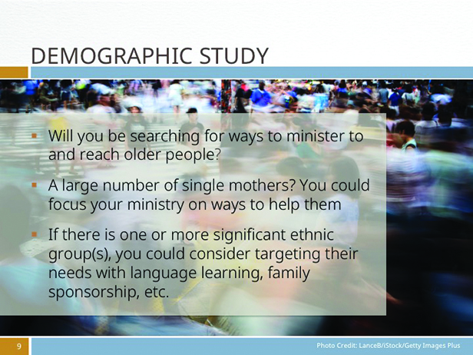 |  | Most countries do some type of demographic study of areas within their borders. Demographics give the statistical characteristics of a population often gathered through a census. The results may be found on a government web site. This kind of research includes such things as how many people live in the community, their gender makeup, ethnicity, age, average income, unemployment levels, home ownership, and religious affiliation. This can be incredibly helpful in understanding the people who make up your target community and can help make you aware of possible needs. For instance:  - If you discover that a large segment of the population is elderly, you will know that you will be searching for ways to minister to and reach older people.  2. If you discover that the region is home to a number of single mothers, this could focus your ministry on ways to help them.  3. If you discover there is one or more significant ethnic group(s) in your community, you could consider targeting their needs with language learning, family sponsorship, etc.  The study of demographic trends (they change over time in every community) can be helpful in understanding potential growth within the community. For instance, a continuing growth in the number of families with young children moving into the area could suggest a need for an approach focused on these family groups. People who move to a new community tend to be more open to other changes in their lives as well and may be open to the gospel.
 | PSYCHOGRAPHIC PROFILING
 | Slide 10
 |  | A recent addition to studies on communities is what is called psychographic profiling. It goes further than demographics and reports on things such as personality types, values, attitudes, interests, and lifestyles. This is important information for anyone wanting to understand a community (marketers use this approach as research for their advertising), but it is not widely available yet and is quite expensive to have done.

 |  | WALKING SURVEY
 |  | Slide 11
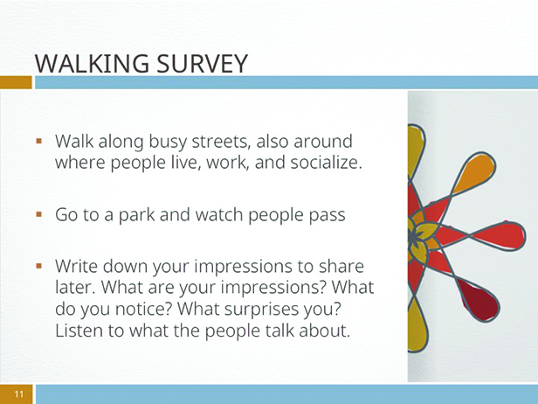 |  |  |  | It’s useful to take a walk or drive through the community. Do this in pairs so you can compare observations while on site. Walking is best but may be impossible if the area is large. However, even in large areas you can walk through areas where people gather and just observe them. Walk along streets where people live, where they work, and where they socialize. Go to a park and watch as people come and go. Sit in a café and watch people inside and those passing by. Walk along busy streets. Mingle. What are your impressions? What do you notice? What surprises you? Listen to what the people talk about. Write down your impressions to share later. Look for the kind of information that will help you understand this community. It’s important to have several members of your team--or better yet, the whole team--do this so you can share your discoveries and observations.
 |  | INTERVIEW COMMUNITY LEADERS
 |  | Slide 12
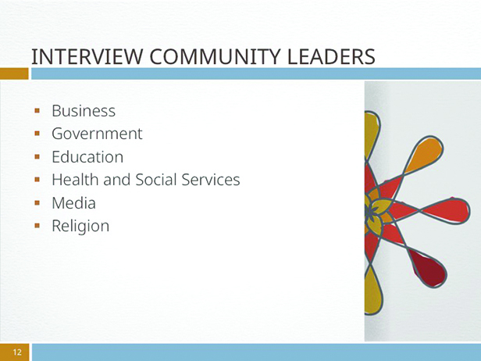 |  |  |  | Ask the locals in the neighborhood who know the needs in the community. There are leaders from six groups of people worth talking to. Ask for an interview with them.  The business sector  This includes those who own small businesses such as shops, restaurants, vending carts, and services such as plumbers and barbers. It also includes managers of local outlets of national and international companies such as supermarket chains, department stores, fast food companies, and so on. The business sector usually comes under the umbrella of a group, sometimes called the Chamber of Commerce. You could make an appointment to meet with a couple of members.  The government sector  This is made up of elected officials of the community such as the mayor or council members. It also includes those involved in police and fire services. In larger cities you will find that each of these agencies has community relations people you can talk to.  The education sector  Education includes both government and private education institutions. The principals of schools in the community--public as well as private—are important leaders to be interviewed.  The health and social services sector  These services are provided by a number of organizations--some of them government, some non-governmental organizations (NGOs)--and in some countries private-practice professionals such as physicians, dentists and counselors. It would be helpful to interview someone who ranks high in health care as well as government officials working in the social services sector.  There may be such things as a homeless shelter or refugee camp in the community. It would be good to interview the leaders of these groups. Are there professionals working in preventative medicine or involved in HIV-AIDS work? Are there trained social workers to help with a needs assessment?  The media sector  While it has been suggested that you read, listen to, and view media; it is also helpful to take the time to interview the editor of the local newspaper (or a representative), to talk to the news editors or community relations person of other media. Interview them.  The religion sector  Religion is an important part of any community, no matter how secular the country. It is a good idea to interview the local religious leaders (pastors, priests, rabbis, imams and so on) of the major faiths in your area. Remember that you are there to gather information about community needs, listening carefully to what they say, and don’t argue with them.
 |  | HOW TO DO AN INTERVIEW
 |  | Slide 13
Make an appointment ahead of time—phone ahead or go to their office. You will be asked what the purpose of the appointment is. You can say, “My church is doing a community assessment and we want to interview key leaders to hear about needs in this community.”
Prepare for the interview by writing down a brief list of questions you need to ask about their area of expertise. Familiarize yourself with the questions before the interview. Remember that you want to know what is already happening and, from their perspective, what is not happening that should be addressed.
In the interview, introduce yourself briefly and thank the person for their time. Assure them that the interview is for information only and they will not be quoted in any report, and that comments will be anonymous. Do not be tied to your questions. As you talk and listen important follow-up questions will arise. Take brief notes during the interview. Flesh those notes out as soon as possible after the interview. If possible, have someone go with you to the interview to help remember key details.
 | Following the Jesus method
 | slide 14
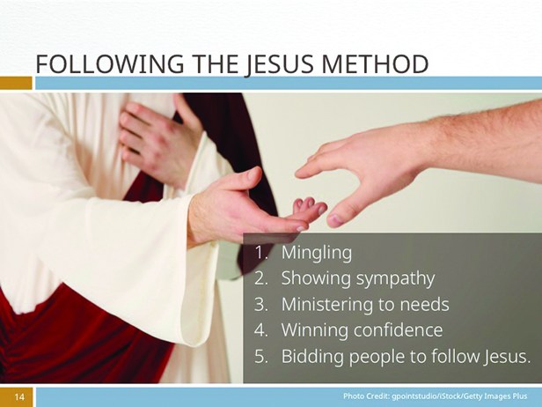 |  |  | The Jesus Method—as outlined by Ellen White—builds strong, multi-leveled connections between people and God in the following ways and, usually, in the following order:  1. Mingling  2. Showing sympathy  3. Ministering to needs  4. Winning confidence  5. Bidding people to follow Jesus.  Today there are few occasions in which you can go into a community and begin by bidding people to follow Jesus with great success.  Now that you have done your research and assessment, you need to work on a plan and a process in which these five elements are emphasized.  In your planning, aim to work with the people not for them. Working for them implies that you know what is good for them, what they need, and that you are there to rescue them. Working with them means you are working together. You are walking in their shoes.  Having done your research and discovered the needs in the community, you may have found that there are organizations already in place helping to fill these needs. Why not join one of them to assist in helping? This gets you mingling with helpers in the community and their clients; you are seen as showing sympathy; and you are ministering to needs in the community through an already recognized agency—an agency that has already been accepted.  It is worth remembering that without the need to set up and administrate another organization you are freer to follow the Jesus Method. Of course, if there are needs not being cared for, that creates an opportunity to assist the community in that area. You need to work with the community and to start small.  If, after your research is completed and there seems to be no formal way of helping people, you and your team can help those in need. It could be in simple ways. After all, your main role is to connect with people. These can become lifechanging connections, binding people’s hearts, minds, and souls to Jesus.

 | slide 15
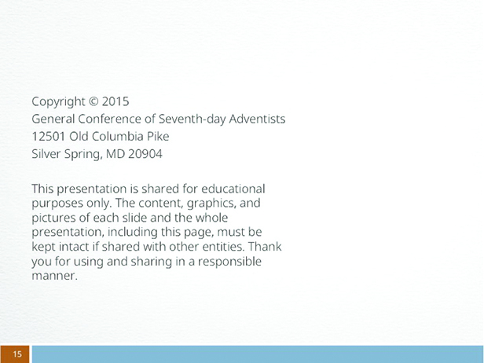 |  | Credits

Personal assessment worksheet

Rate yourself between 1 (strongly negative) and 10 (strongly positive) to the questions asked in the personal assessment area. Be honest.
1. Has this challenge been the center of my prayer life? | 1 + + + 5 + + + + 10
2. Am I in a strong and personal relationship with God and in a saving relationship with Jesus? Am I dependent on God’s leading in my life? | 1 + + + 5 + + + + 10
3. Am I prayerfully allowing God to lead in this endeavor? | 1 + + + 5 + + + + 10
4. Am I motivated to do this because of my love for Jesus or am I doing this for myself? | 1 + + + 5 + + + + 10
5. Am I willing to be a part of a team and willing to come under the rule of the team’s “group wisdom?” | 1 + + + 5 + + + + 10
6. Am I planning to be an involved part of the town, city or community, or as the rescuer who plans to help save these people from themselves? | 1 + + + 5 + + + + 10
7. Am I willing to move into the community? | 1 + + + 5 + + + + 10
8. Am I prepared to work for the greater good of the community rather than for short-term personal gains? | 1 + + + 5 + + + + 10
What is this telling you?
Start with a map
Take your time as you look at your map. List the things you notice, particularly the things that help you understand the community. (For instance, a university or a lake that would suggest certain types of people and activities.)

Local media and websites
List what you discover about the main interests and concerns of the community from the media.

In what ways are people hurting in the community?

In what ways do you feel that you would like to help with the needs you discover in this media reflection? (It isn’t the time to act yet, but a time of gaining awareness.)

Demographic study (and psychographic profiling)
What does the demographics of your community tell you about:
- The age range
- Significant ethnic groups
- Income
- Unemployment
- Religious affiliation

Is there any other significant information you find?

As you reflect on this information, what dreams for helping the people are coming to the front?

Walking survey
Write down your impressions of the community here.

Interviews
Having done the interviews, what needs stand out? Put them into two lists, those that are easy to work with and those that would be more difficult. You may also need to list those that you don’t have the resources to attempt.

Having gathered the information
You will probably have a whole range of information. Now is the time to begin to sift through it and list the top five or six (the number doesn’t matter), but the focus on a few does) that really stand out in your mind and heart. What are they?

Which of these are already being tackled by another organization?

Which of these are not being handled by anyone?

Following the Jesus Method
Finally, how can you best serve your community by following the Jesus Method?

- Mingling
- Showing sympathy
- Ministering to needs
- Winning confidence
- Bidding people to follow Jesus.

