one-day events & activities
session 2. FESTIVALS & EVENTS
Q. Rajkumar Dixit

 |  |  | overview

course kit contents:
- Presenter’s guide
- PowerPoint slides

Materials Needed
- Leader’s notes
- PowerPoint
- Computer (for the PowerPoint presentation)
- Projector and screen
- Tables and chairs
- Pens or pencils
- Sound system (for large classes)

Tips and Guidelines
1. |  |  | Come prepared.  Review the entire content and handout materials before the session. Arrive early for your presentation. Set up your equipment and test everything before the participants arrive.
2. |  |  | Greet the participants as they arrive.  One of our goals is to build relationships within the community. Greeting people as they enter puts them at ease and can open doors for further dialogue.
3. |  |  | Start on time.  The presentations are designed to be less than 1.5 hours. Honor that time frame.
4. |  |  | Welcome students and introduce yourself.  This introduction should take only 30 to 60 seconds.
5. |  |  | Introduce the topic of the presentation.  A brief introduction appears in the script under slide 2. Keep it short. Introductions should get the participants’ attention, not bore them.

6. |  | Distribute the participant worksheet for note taking.
7. |  | Give the PowerPoint presentation.
8. |  | Introduce and distribute the quiz.  Detailed instructions are given in the script. Have the participants work in small groups of two to four, discussing and completing the quiz together. (If the nature of your group warrants it, lead the discussion of the quiz questions from the front, soliciting responses from the participants.) Give the participants about 20 minutes to complete the quiz. Monitor the participants’ progress, adjusting the time as needed to allow them time to complete the worksheet. Then call them back together as a group and discuss the answers using the answer key.
9. |  | Closing remarks and reminder.  Introduce the next session’s topic, and remind them of the date, and time of the session.
10. |  | Thank the participants for coming and visit with them as they are leaving.

WELCOME

 | Slide 1
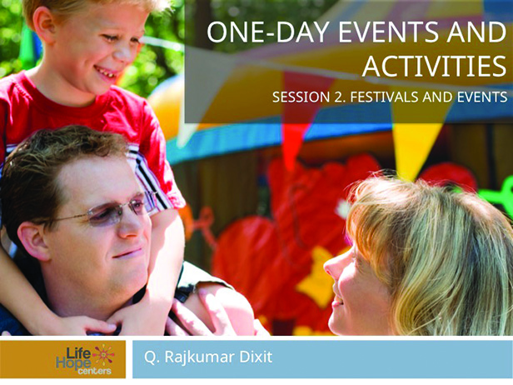 |  | Make sure you have 3 to 6 months to plan for this event. You will need a planning team of 6 to 8 people to organize the fair.
 | Children’s Fair
 | Slide 2
 |  | Your planning committee should consist of hardworking individuals who have had experience organizing other programs and events. The people who serve on this committee must have influence, follow up on assigned tasks, and can build a team to help see plans through to completion. Each member of the committee should have 5 to 7 individuals working with them to complete their assignments.
 | Planning committee Membership & Responsibility
 | Slide 3
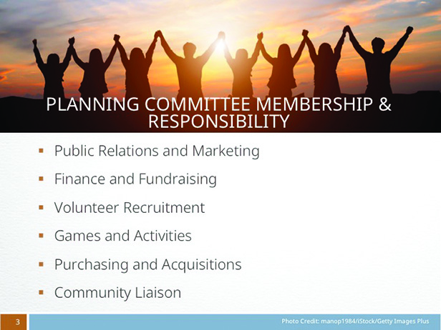 |  | - Public Relations and Marketing  - Finance and Fundraising  - Volunteer Recruitment  - Games and Activities  - Purchasing and Acquisitions  - Community Liaison
 | Public Relations and Marketing
 | Slide 4
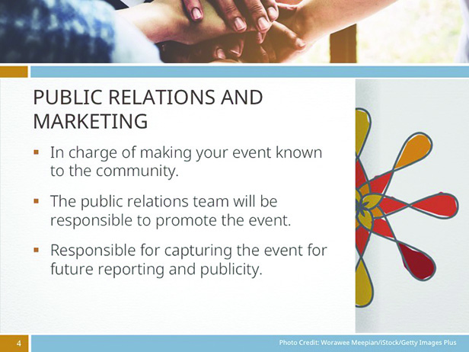 |  | The Public Relations and Marketing team is in charge of making your event known to the community. They need a robust group of people to get the word out. The public relations team will be responsible to produce posters, fliers, and digital art as well as use social media, website, and interviews to promote the event. In addition, the public relations team should be prepared to hire or act as photographers and videographers to capture the event for future reporting and publicity.
 | Finance and Fundraising
 | Slide 5
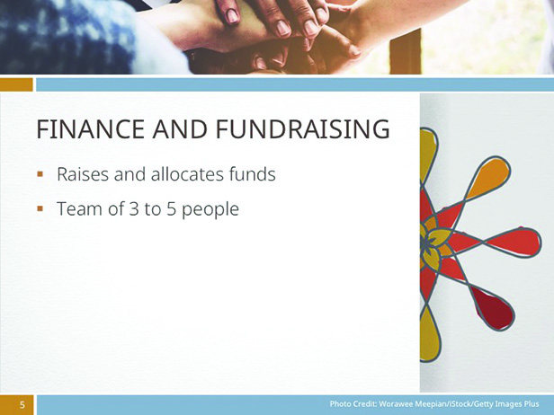 |  | The person responsible for finances should plan ways to raise additional money as well as allocate funds from the fixed budget. The chairperson should build a team of 3 to 5 people to seek corporate and local business sponsorship of the event.
 | Volunteer recruitment
 | Slide 6
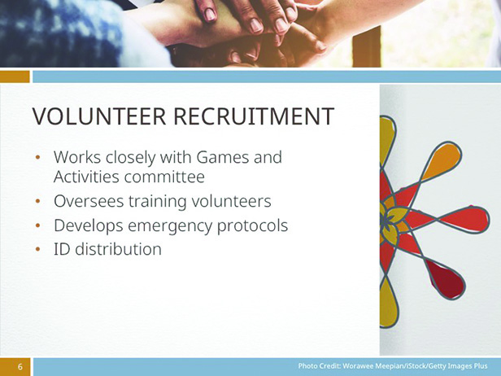 |  | The leader of this committee will recruit, welcome, and train volunteers. The team will work closely with the Games and Activities committee to determine the kind of games, and number of volunteers needed during the event. In addition, the volunteer recruitment team will oversee training volunteers, developing emergency protocols in case there was a disastrous event such as a fire, distribute staff identification badges and appropriate volunteer t-shirts.
 | Games and activities
 | Slide 7
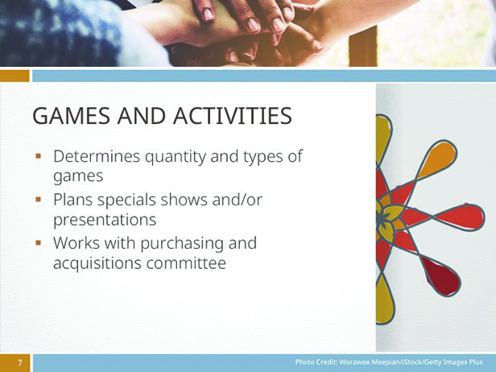 |  | This committee will determine how many and what types of games and activities will occur at the event. The committee will also plan special shows or presentations such as musical selections from a local band. The leader will festivals & events work  with the purchasing and acquisitions committee to order the supplies, games, and large equipment needed.
 | Purchasing and acquisitions
 | Slide 8
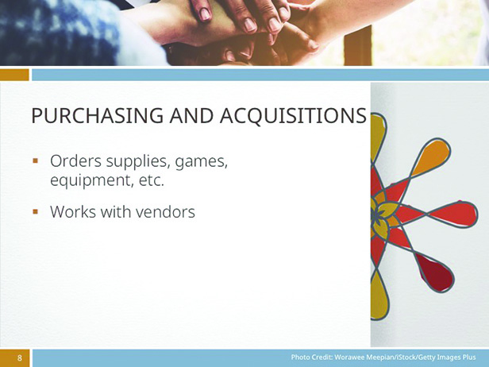 |  | This committee will order all of the supplies, games, equipment, etc., for the event. They will work with the other committees to ensure that all supplies have been ordered and logged. Be certain to work with vendors to get the best prices and maximum discounts. Ask your team to create a list of 10 businesses in your local community. Invite these local venders to become sponsors of the fair.

 | Community liaison
 | Slide 9
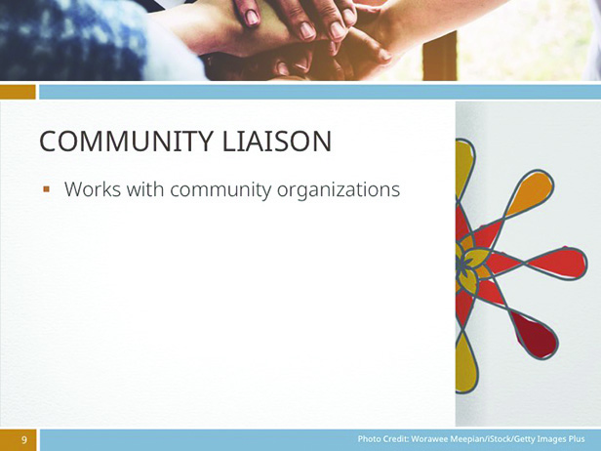 |  | This team will work with all of the community organizations, schools, and volunteer groups to build good will. Once relationships are built, you can ask these groups to partner with you on this event. For example, if there is local food market in your neighborhood, ask them to support the fair by selling a specific product (cashews, health drinks) at the fair. This will provide visibility for the local merchant, and simultaneously build good will. You can also ask for volunteers from their organization, ask them to serve as corporate sponsors, and organize a special program or show during the fair. For example, if you are partnering with a local elementary school, ask their choir or band to perform at the event.
 | Checklists
 | Slide 10
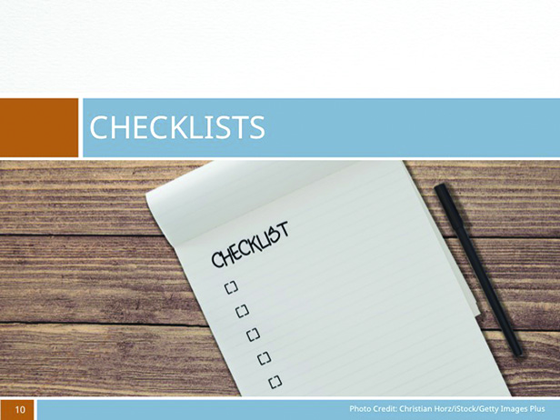 |  | - 6-months prior  - 4-months prior  - 3-months prior  - 2-months prior  - 1-month prior  - General equipment

 | 6-month checklist
 | Slide 11
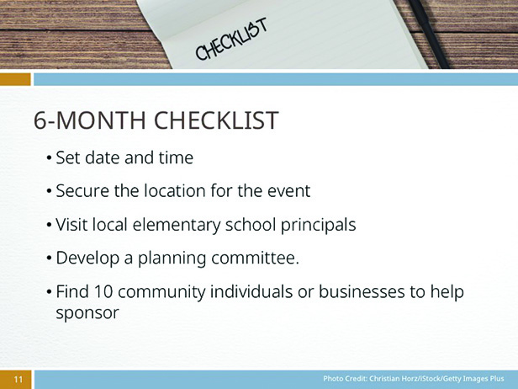 |  | - Set the date and time for the fair.  - Secure a location for the event. If possible, try to hold the fair on or near the grounds of the Life Hope Center to give the best exposure for the center and to let the community know what the center does.  - Visit the local elementary school principals and invite the school to participate in the community event.  - Develop a planning committee. Include two people from the community on the planning committees. Ask a local merchant or an elected official who already has a community connection.  - Find 10 community individuals or businesses to help sponsor the event.
 | 4-month checklist
 | Slide 12
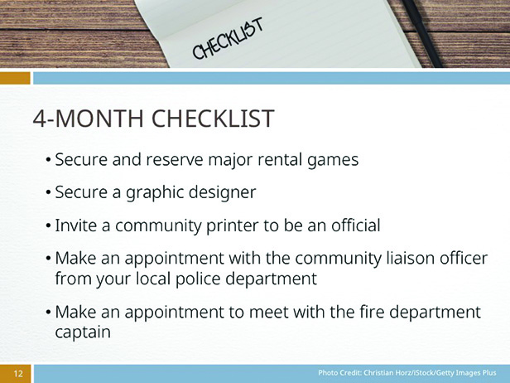 |  | - Secure and reserve major rental games (i.e., moon bounce, etc.). Double check with the rental company that they will deliver, set up, and pick up the equipment on specific dates.  - Secure a graphic designer to help develop posters and logos.  - Invite a community printer to be an official sponsor of the event. Ask them to donate the cost of the printing or offer a heavy discount in exchange for the publicity and acknowledgement.  - Make an appointment with the community liaison officer from your local police department. Ask them to bring a team of officers to provide educational presentations at the event.  - Make an appointment to meet with the fire department captain. Ask the fire department to bring a fire truck to the event and allow the children to explore the vehicle and ask questions about fire safety.
 | 3-month checklist
 | Slide 13
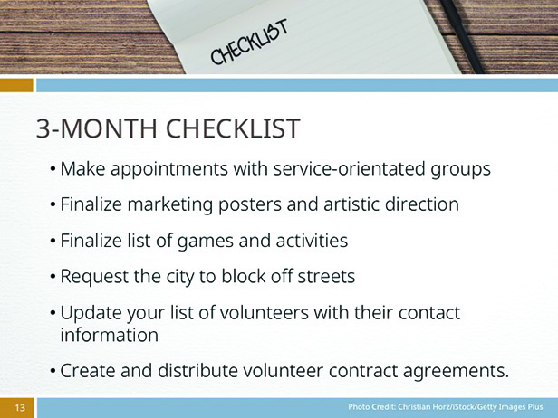 |  | - Make appointments with local chapters of the Rotary, Kiwanis, or other service-orientated groups to attend the children community fair and provide a booth for the adults with information about their organizations.  - Finalize the marketing posters and artistic direction.  - Finalize on the list of games and activities.  - Make the appropriate requests from the city to block off any streets.  - Update your list of volunteers with their contact information to see whether any areas still need help.  - Create and distribute volunteer contract agreements.
 | 2-month checklist
 | slide 14
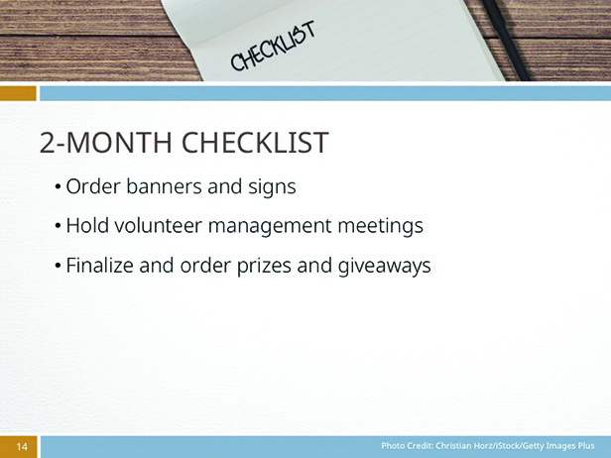 |  | - Order banners and signs.  - Hold volunteer management meetings. Meet with the volunteer leaders to follow up on progress and discuss solutions to logistical problems that may arise.  - Finalize and order prizes and giveaways.

 | 1-month checklist
 | slide 15
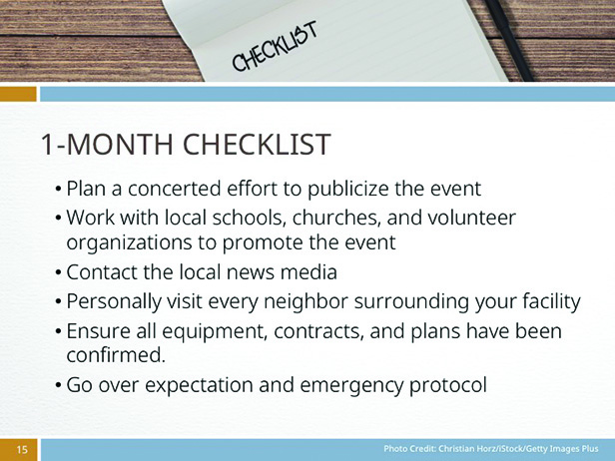 |  | - Plan a concerted effort through social media to publicize the event.  - Work with local schools, churches, and volunteer organizations to promote the event through postcards and posters.  - Contact the local news media and ask them to cover the event.  - Personally visit every neighbor surrounding your facility, informing them of the upcoming event and inviting them to participate. This will alleviate any future problems with complaints regarding parking, sound, etc.  - Double check with your committee leaders to ensure all equipment, contracts, and plans have been confirmed.  - Meet with your event volunteers to go over expectation and emergency protocol and thank them in advance for their time and energy.
 | General Equipment checklist
 | slide 16
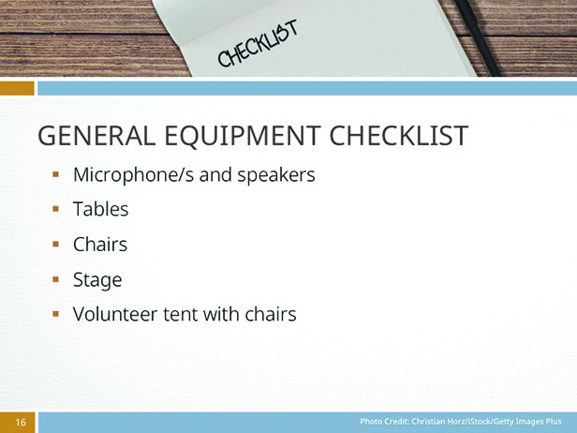 |  | - Microphone/s and speakers  - Tables (you will need one six-foot long table for every 2 volunteers)  - Chairs  - Stage  - Volunteer tent with chairs, drinks and snacks to serve as a break room for volunteers and staff

 | International festival
 | slide 17
Host an international festival; invite people from several cultures to set up tables or booths that feature crafts, games, and food from that culture/region. Encourage each ethnic group to include activities such as teaching a few words in one of the local languages, displaying traditional musical instruments, or teaching visitors to play a game popular in their culture. Offer samples of favorite cultural foods to try and/or sell.
Set up a stage on which groups from various cultures can perform traditional music and/or folk dances.
Charge an admission (perhaps $5 a person) and let people know that proceeds will go to a specific project in the community. For more ideas, check archived issues of the Children’s Mission online at AdventistMission.org. Click on Activities and search for language, songs, games, and flags.
 | slide 18
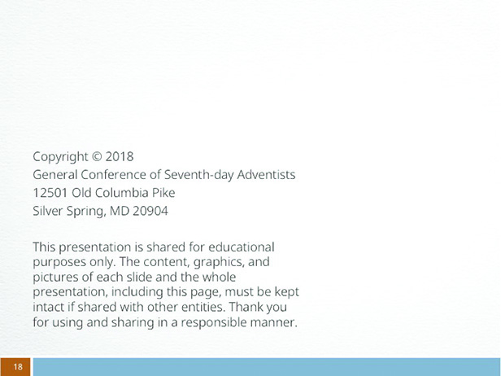 |  | Credits

Appendix A: SAMPLE VOLUNTEER CONTRACT
SOURCE: Volunteering Waikato http://volwai.org.nz

Note: Fill in all necessary information [listed in italic in form] and format with your organization’s name and contact information. Ask each volunteer to read and sign a copy.
Organization Name (Use the organization’s legal name)
As a volunteer I agree to:
▪ Abide by and support the philosophy, policy, and guidelines of the organization
▪ Act in the best interests of the organization
▪ Maintain confidentiality
▪ Abide by safety and risk management requirements
▪ Carry out the tasks outlined
▪ Attend training seminars on the agreed-upon time and day or contact [insert name and phone number], if I am not available
▪ Participate in orientation, meetings, and training (e.g. minimum of 10 hours per volunteer required)
▪ Maintain a record of my volunteer hours and ensure that information is given/posted to [name and position] by the due date
▪ Raise any matters of concern with [name, position].

The Organization agrees to:
▪ Provide information about the organization
▪ Provide orientation, support, training, and supervision
▪ Provide a safe working environment
▪ Provide opportunities for input into the organizational plan and evaluation
▪ Reimburse for pre-approved expenses
▪ Acknowledge and recognize the contribution of volunteers to the organization

Volunteer’s name _________________________________________________________________
Volunteer’s signature _____________________________________________________________
Date _______________________________________________________________________________
Volunteer Coordinator’s name ____________________________________________________
Volunteer Coordinator’s signature ________________________________________________
Date __________________________________________

