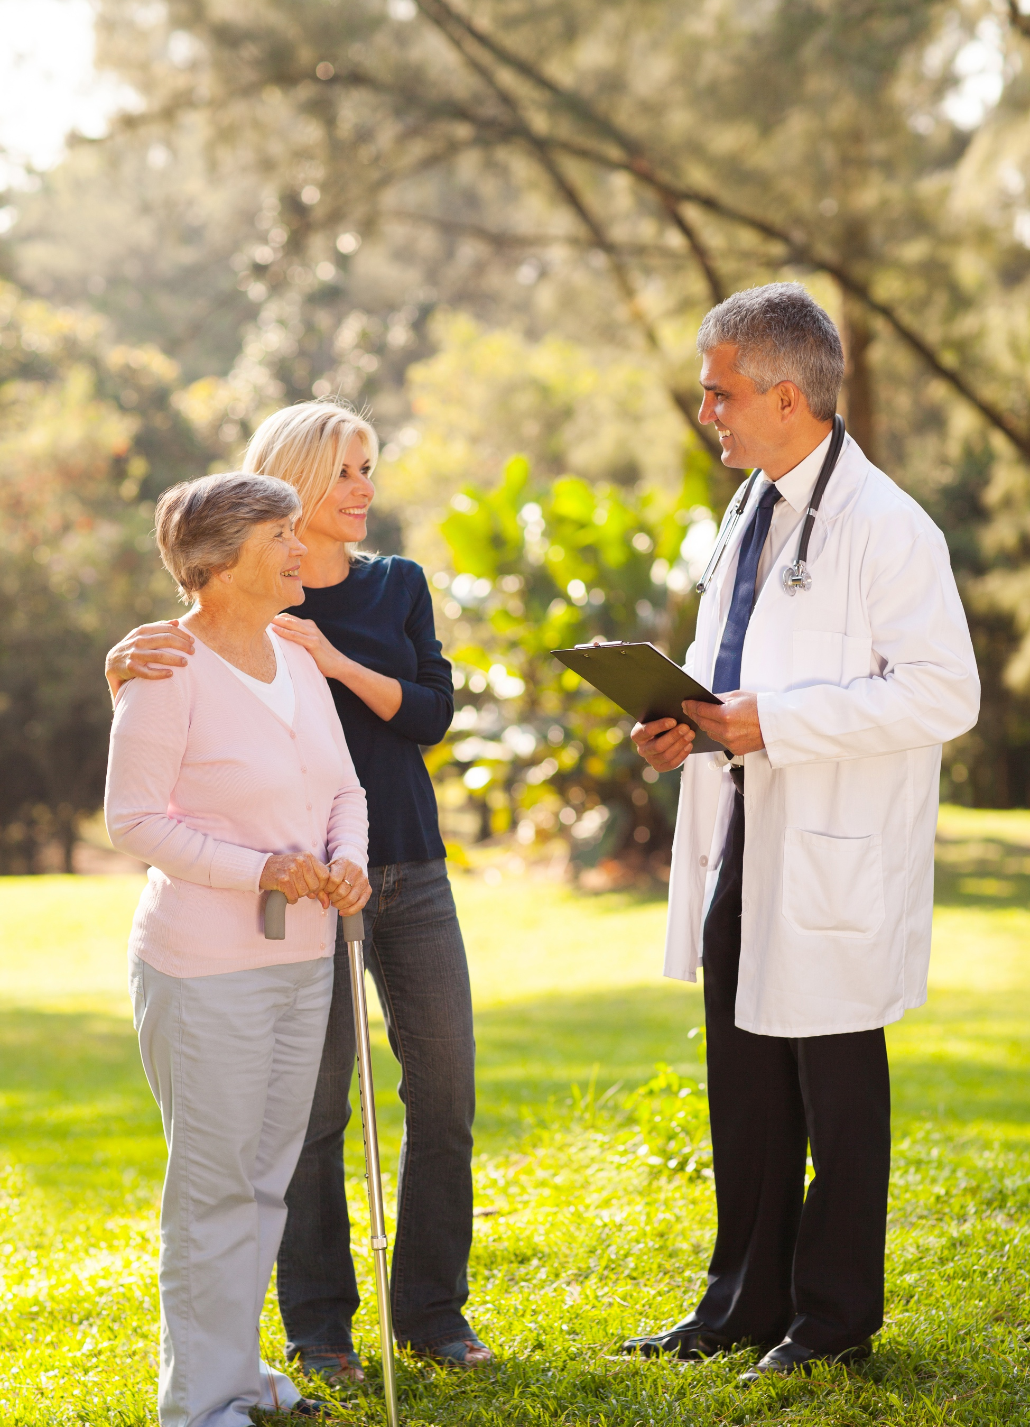

one-day events & activities
session 3. helpting the community

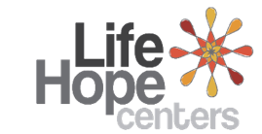
Q. Rajkumar Dixit
 |  |  | overview

course kit contents:
- Presenter’s guide
- PowerPoint slides

Materials Needed
- Leader’s notes
- PowerPoint
- Computer (for the PowerPoint presentation)
- Projector and screen
- Tables and chairs
- Pens or pencils
- Sound system (for large classes)

Tips and Guidelines
1. |  |  | Come prepared.  Review the entire content and handout materials before the session. Arrive early for your presentation. Set up your equipment and test everything before the participants arrive.
2. |  |  | Greet the participants as they arrive.  One of our goals is to build relationships within the community. Greeting people as they enter puts them at ease and can open doors for further dialogue.
3. |  |  | Start on time.  The presentations are designed to be less than 1.5 hours. Honor that time frame.
4. |  |  | Welcome students and introduce yourself.  This introduction should take only 30 to 60 seconds.
5. |  |  | Introduce the topic of the presentation.  A brief introduction appears in the script under slide 2. Keep it short. Introductions should get the participants’ attention, not bore them.

6. |  | Distribute the participant worksheet for note taking.
7. |  | Give the PowerPoint presentation.
8. |  | Introduce and distribute the quiz.  Detailed instructions are given in the script. Have the participants work in small groups of two to four, discussing and completing the quiz together. (If the nature of your group warrants it, lead the discussion of the quiz questions from the front, soliciting responses from the participants.) Give the participants about 20 minutes to complete the quiz. Monitor the participants’ progress, adjusting the time as needed to allow them time to complete the worksheet. Then call them back together as a group and discuss the answers using the answer key.
9. |  | Closing remarks and reminder.  Introduce the next session’s topic, and remind them of the date, and time of the session.
10. |  | Thank the participants for coming and visit with them as they are leaving.

WELCOME

 | Slide 1
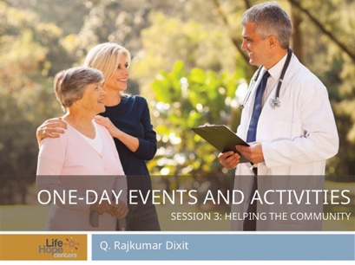 |  | A health fair is a positive way to build relationships and generate goodwill within your community.
 | Health fair & medical clinic
 | Slide 2
Objectives
A health fair can accomplish several key things:
- Build awareness in the local community regarding healthful living and disease prevention.
- Increase public awareness concerning childhood nutrition and at-risk diseases among certain population groups.
- Encourage participants to adapt healthful lifestyle practices.
- Teach the community how to shop for healthful, affordable food.

 | Preparation & Planning
 | Slide 3
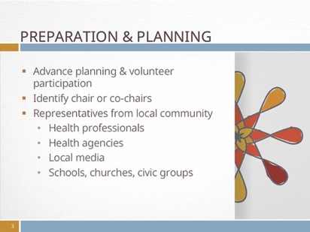 |  | Organizing a large event such as a health fair requires advance planning and strong volunteer participation. Put the initial steps in place one year in advance. The first priority is to identity a chair or co-chairs. The planning committee should have representatives from your local community to ensure collaboration and unity. Some examples include the following:  - Health professionals  - Health agencies  - Local media  - Schools, churches, civic groups
 | Slide 4
 |  | Health professionals: physicians, nurses, nurse practitioners, dentists, chiropractors, optometrists, physician assistants, audiologists, etc.
 | Slide 5
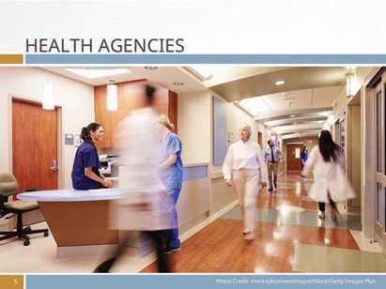 |  | Health agencies: representatives from hospitals, home-health care services, nursing homes, hospice care, medical colleges, medical emergency companies.

 | Slide 6
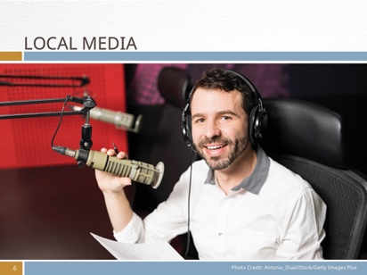 |  | Local media: newspapers, television station, radio, etc.
 | Slide 7
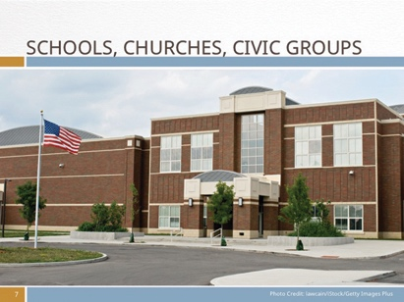 |  | Schools, churches, civic groups: Elementary and secondary schools, churches, civic groups such as Rotary.
 | Develop community partners
 | Slide 8
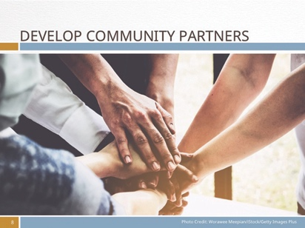 |  | The success of the health fair will depend on the community partners you form a relationship. Make a list of the local health organizations and clinics in your community that may be willing to provide free services at the fair. Work with the public relations or community development officer of these organizations and facilities to assist in the planning and executing of the health fair.
 | Slide 9
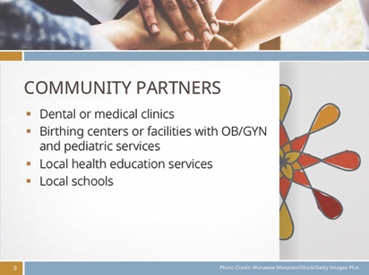 |  | Community Partners:  - Dental or medical clinics in the neighborhood  - Birthing centers or facilities with OB/GYN and pediatric services  - Local health education services that can provide nutrition, weight control, and other health information  - Local schools in the neighborhood
 | Activities and programming
 | Slide 10
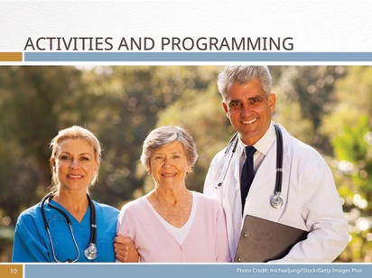 |  | Depending on your community partners and the level of expertise of your volunteers, consider offering some or all of these activities. Each of these activities will need to be adapted based on the health needs of your community, and the experts available. The following are some suggestions for possible activities to hold during the health fair.
 | Slide 11
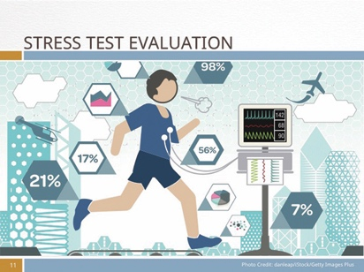 |  | Stress test evaluation. This test will help determine the probability of coronary artery disease and can identify abnormal heart rhythms. In addition, it will give attendees a measuring tool to help them develop a safe exercise plan and a cardiac treatment program, if necessary.
 | Slide 12
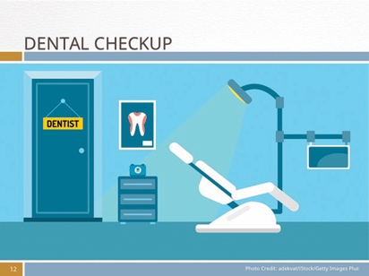 |  | Dental checkup. A dentist can provide a cursory evaluation by examining the mouth and teeth. While the best examination requires an x-ray of the teeth, a visual appraisal will remind the person to be more diligent in oral care such as brushing and flossing. The dentist can also identify tooth decay and potential bone loss while answering questions. Give each person who completes a brief examination a free toothbrush and toothpaste.

 | Slide 13
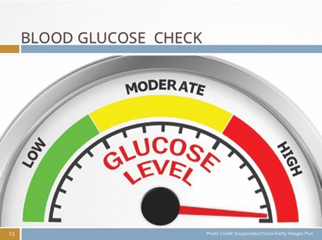 |  | Blood glucose check. As diabetes rates around the world continue to skyrocket, checking a person’s blood glucose level can help identity diabetes and pre-diabetes. The person could receive counseling on how to avoid foods that contribute to high glucose levels and live a more healthful, active lifestyle. helping the community.
 | slide 14
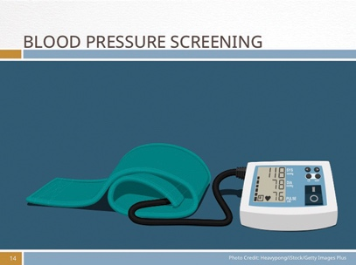 |  | Blood pressure screening. High blood pressure is often called the “silent killer” because it affects your arteries, heart, and other organs, but it has no symptoms until something catastrophic occurs such as a stroke or heart attack. A simple blood pressure test can identify potential problems. Based on the person’s results, appropriate counseling could be offered to help participants identify the next steps in their healthcare plan.
 | slide 15
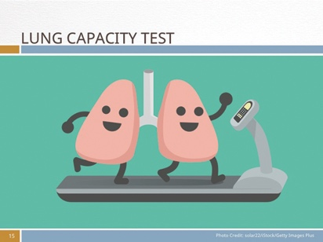 |  | Lung capacity test. Also known as pulmonary function test, this test can evaluate how well a person’s lungs are working by measuring how much air the lungs can hold and how well the lungs provide oxygen to the blood while removing carbon dioxide from the blood.
 | slide 16
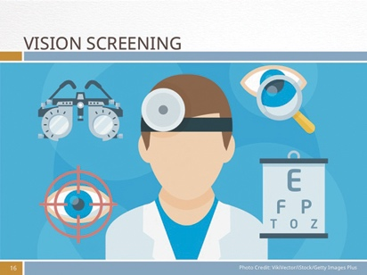 |  | Vision screening. Having an eye checkup isn’t about getting new glasses. It is an essential health check for your entire body. An eye test can identity diseases such as glaucoma, diabetes, and high blood pressure. Many older adults avoid taking the time to have their eyes checked, which could affect their reading and driving ability, among other things. But children should be screened as well for potential eye problems that can affect their ability to complete schoolwork.
 | slide 17
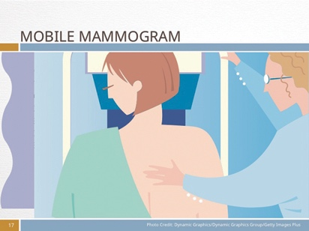 |  | Mobile mammogram. Depending on your location and availability, a mobile mammogram may be a viable option for women. Screening mammograms are considered one of the best tools for early detection of breast cancer. The mobile unit can screen women who may not ordinarily take the time to schedule an appointment or who cannot afford the test in a private facility. Work with your local health provider to inquire about availability and provide a private room and a female technician to perform the test.
 | Slide 18
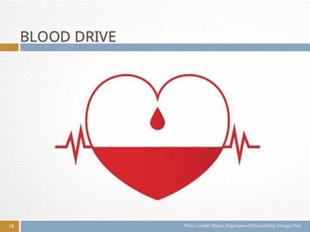 |  | Blood drive. One of the better ways to show community connection and support is by organizing a blood drive at your health fair. The local blood bank in your community can assist you in offering this activity. They will help you with the logistics and provide cots, supplies, and trained volunteer personnel.
 | slide 19
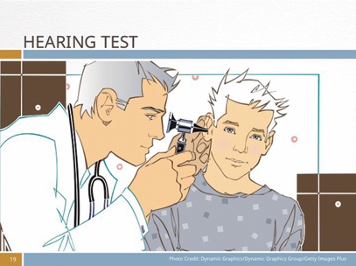 |  | Hearing test. People often don’t realize that their hearing has deteriorated. Sometimes hearing loss can be due to something as simple as earwax buildup. Have the person fill out the Hearing Test Screen Form on page 22 of Leader’s Guide. This will help lower the participant’s anxiety before they take the hearing test.
 | slide 20
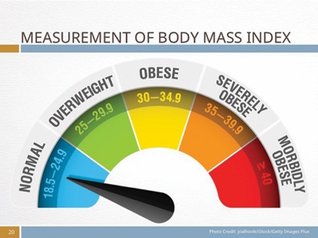 |  | Measurement of Body Mass Index. Attendees learn how to calculate their BMI based on height and weight. This is a gauge to determine body fat in most adults. An elevated BMI can result in obesity, high blood pressure, cardiac problems, and diabetes, among others. Give out information on how to lower your BMI.
 | slide 21
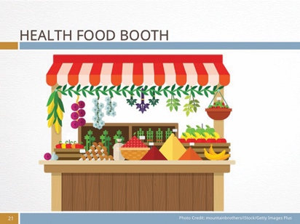 |  | Health food booth. Provide one or several booths that offer nutritious and fun foods rather than the traditional sugary or refined foods normally encountered at a fair. Focus on fresh fruits and vegetables, tossed salads, low-fat options, alternatives to meat (such as lentil stew, brown rice and stir fry) or bean burgers on whole-wheat buns, fruit smoothies (made from fresh or frozen fruit and soy or almond milk or fatfree plain yogurt) for sale at a reasonable price. Encourage people to think healthy.
 | Seminars for now or later
 | slide 22
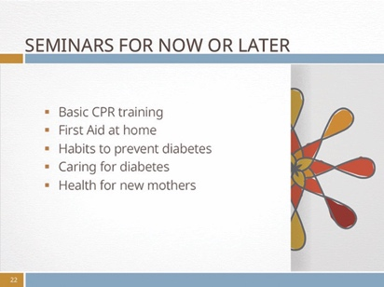 |  | The health fair is a good occasion to get people moving and learning. While the above health stations provide ample opportunities to receive personalized attention, there are other ways to educate your community regarding important health issues. Some seminar ideas you can try at the fair or offer as incentives to attend other events at the Life Hope Center include:
 | slide 23
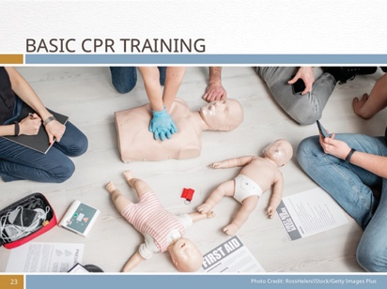 |  | Basic CPR training. This seminar will teach participants how to be prepared to save a life. Many people are shocked when they encounter a critical life event; they may become paralyzed with fear. This seminar will teach the participant the essential steps in basic first aid, how to use cardiopulmonary resuscitation (CPR), and how to perform the Heimlich maneuver to aid someone who is choking—vital lifesaving skills that are useful in the workplace and at home.
 | Slide 24
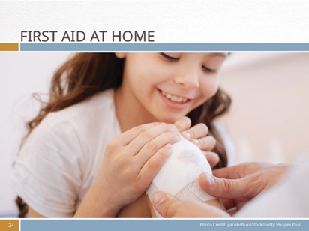 |  | First Aid at home—what every parent should know. What do you do when your child is choking? How do you care for a puncture wound, excessive bleeding, or a burn? When should you see a medical practitioner, and when can you treat an injury yourself? This seminar will teach parents and childcare providers to be ready for some of the most common medical emergencies.
 | slide 25
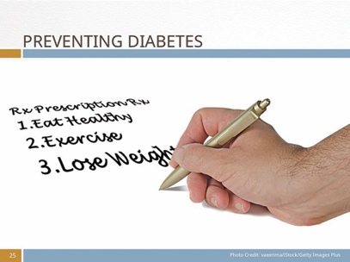 |  | Forming habits to prevent diabetes. While the incidence of Type 2 diabetes is growing rapidly in the developing and developed world, prevention is possible. Learn to make the necessary lifestyle changes to prevent the onset of this disease as well as help others control their glucose levels.

 | slide 26
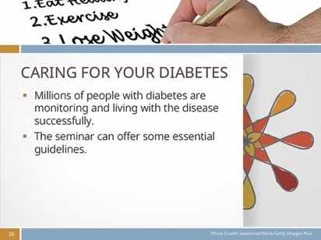 |  | Caring for your diabetes. If left improperly treated, diabetes can affect the feet, eyesight, kidneys, and heart. It can lead to stroke or heart attack. The good news helping the community is that millions of people with diabetes are monitoring and living with the disease successfully. The seminar can offer some essential guidelines on how to live an active and vibrant life with good eating and exercise habits.
 | slide 27
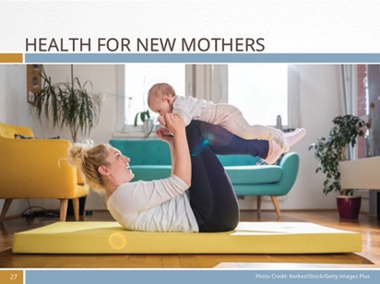 |  | Health for new mothers. This seminar can address specific issues such as challenges with breastfeeding, a mother’s mental health, and making time for self-care. Provide childcare during the seminar.
 | Other seminar topics
 | slide 28
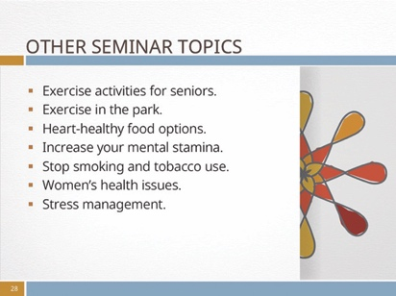 |  | Other seminar topics can include:  - Exercise activities for seniors.  - Exercise in the park.  - Heart-healthy food options.  - Increase your mental stamina.  - Stop smoking and tobacco use.  - Women’s health issues.  - Stress management.
 | Engaging Children
 | Slide 29
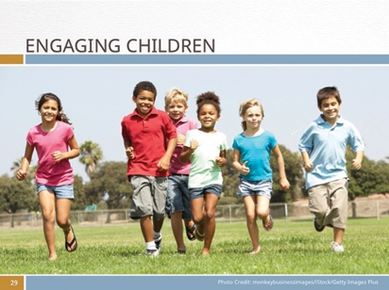 |  | While most of these activities and seminars at the health fair relate directly to adult needs, a large portion of attendees at the fair will be children who accompany their parents. What kind of activities can you plan for children? Consider creating a “kids’ village” that includes musical acts or a clown to engage children in some fun activities that get them moving. In addition, incorporate games that encourage movement and imagination. Here are a few game suggestions:
 | slide 30
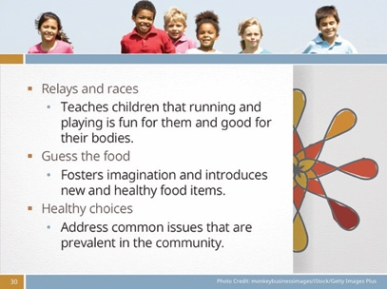 |  | Relays and races. Arrange relays and races on a simple course. Include some relays that require skill and toss in some adult competition to make things more interesting and fun. Try racing to a finish line holding an egg (raw or boiled) on a spoon or a cup of water. If the water spills below a given line, the competitor must return to the start and refill the glass. Teach children that running and playing is fun for them and good for their bodies.  Guess the food. Blindfold some of the children and ask them to guess what food is in front of them. They can smell and touch the food. If they guess right, they win a balloon or a pin or other small gift. To add interest, ask the child who has identified the food to categorize it regarding whether it’s a “keeper” or a “tosser.” A keeper is a good-for-you food such as a fruit, vegetable, dairy food, nut, or grain. Tossers may be processed foods such as French fries, macaroni and cheese, or sweet desserts. Include some unconventional food that children may not recognize. The point of this game is to foster imagination and introduce new and healthy food items to children. Be sure to get parental consent before a child touches or tastes a food that could cause an allergic reaction.  Healthy choices. Divide the kids in small groups and give them scenarios to think about and decide how they would handle them. These questions can be built around physical health or emotional health. You can address common issues that are prevalent in the community. For example, you may want to give a scenario about bullying. Ask the children how they would handle a tough situation.
 | Things to consider
 | Slide 31
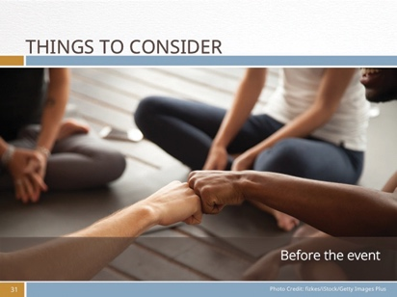 |  | Before the event:  Invite civic leaders and politicians to this event. Invite the mayor, fire marshal, police captain, school officials, etc., to this event. The higher visibility your celebrities achieve, the greater press and media coverage your event will receive.  Provide enough staff to allow breaks for your volunteers. Make sure each booth is adequately staffed so that all volunteers have the opportunity for breaks to eat, visit other booths, or just rest.  Involve large groups from your community to participate in the fair. For example, ask the marching band from the local elementary or secondary school to perform during the day. Each student guest will probably be accompanied by a parent or family members, which will increase your attendance.
 | slide 32
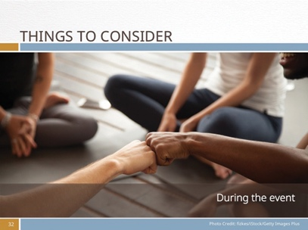 |  | During the event:  Assume nobody knows what to do or where to go. Provide host volunteers near the entrance to guide people and answer questions. Post well-marked signs indicating the name of the different stations and seminars. For example, “Blood Pressure Screening Here” signs should be stationed by the appropriate booth.  Ensure patient confidentiality. While you may have a large group waiting to take a certain test, work with your volunteer staff to protect every patient’s confidentiality. Provide privacy when needed.  Plan to give away prizes every hour. Ask local hospitals and businesses to provide prizes for the drawings, such as a bicycle, cookbooks, a blood-pressure monitor, etc. Participants can register for the giveaway by providing their name and contact information. This information can be used in the future to send out invitations for other activities planned by the Life Hope Center. Many organizations also have publicity items (pens, notebooks, squeeze toys, calendars) that they can give away at a specific booth at the fair. Ask someone to offer bags for all the goodies.  A health fair is an excellent opportunity to build goodwill in your local community. By developing community partners, you will be able to generate greater interest and involve a larger segment of your community. Remember, the healthier the community around you, the more sustainable their future is.
 | Other Community events
 | Slide 33
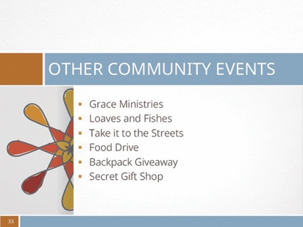 |  | Grace ministries: Set aside one or more days each month (or one day a week) during which low income families can come to the Life Hope Center to receive food, clothing, diapers, household linens, toys and children’s books. Check with local restaurants and grocery stores (or farmers’ markets) for fresh or canned foods that are beyond their sell-by date but still safe to consume. Ask bakeries for day-old breads and rolls. And gather good used clothing, household furniture, and infant and children’s supplies such as diapers, clothes, and baby equipment from those who no longer need them.  During the event, advertise job training opportunities in fields that community residents or Life Hope Center volunteers are qualified to teach, such as a course in basic computers, high school equivalency tutoring, or childcare techniques.  As a special service, provide a closet with professional clothing for men or women who are going to an interview or have just taken a new job.  Offer to help people who have no money pay their utility bills. If shelter is needed for any reason, provide overnight lodging to those most in need, especially mothers with children. Include a hot meal.  Loaves and fishes ministry: Once or twice a month, volunteers from one Life Hope Center drive a van to an under-served community to serve sandwiches, fruit, and milk to the young people living there, and then volunteers play games such as basketball and jump rope with the children of the  community, keeping the kids occupied and away from the gangs in the neighborhood.  Take it to the streets: Once a month ask volunteers to make as many sack lunches as possible (25 to 400) and distribute them to people living on the streets. Provide volunteers with a T-shirt identifying the Life Hope Center. Invite people from the community—whether church members or not—to volunteer to give out the lunches and greet the people who receive the meals.  Food Drive: Life Hope Center can partner with small businesses and individuals in their community to donate food stuffs (perhaps those that that aren’t selling well or are past their sell-by date but are still safe to eat). The small businesses serve as drop off points where people can bring their donations. Life Hope Center volunteers stop by regularly to pick up donations to distribute to the neediest members of the community.  Backpack giveaway for children: Just before school starts, hold a school-supply drive and encourage businesses and individuals to donate school supplies, new backpacks, or money to purchase needed supplies. Invite volunteers from donating businesses to stuff the backpacks with needed school supplies.  Before school begins, invite children whose parents come to the Life Hope Center for food or clothing distribution to receive a backpack of school supplies for each school age child in their family. There should be no name or identifying mark on the bags that can identify the children as having received a free backpack, for this might cause a difficult situation with their classmates  Secret gift shop: At Christmas (or for any major gift-giving event), many children have no money and therefore no chance to give small gifts to family members. Provide the opportunity to give by soliciting gifts for adults and children from businesses and individuals.  Set up a “store” in a room of the Life Hope Center using tables, racks, and display gifts according to age and gender (men, women, teens, children, infants). On a given day or week, invite community members who have visited the Life Hope Center for food or school supplies to bring their children by to “shop” at the Secret Gift Shop. If you wish, you can prepare ahead of time “Secret Shop” money that the children can spend or allow them to spend real money in small amounts for each gift.  Children should have a list of family members for which they can select a gift, and volunteers should accompany the children from table to table to select the appropriate gifts for their list. Limit gift purchase to one gift for each sibling and parent. When the child has selected the gifts  to buy, direct them to another table where volunteers can help the child wrap the gifts and label the recipients.  While the children “shop,” provide an area where parents can enjoy a hot or cold drink while they visit, watch a video, or listen to a discussion on parenting during difficult times. If funds allow, provide an opportunity for parents to select and “purchase” gifts for their children as well.  Do not put all available gift items out at once but replenish tables as supplies diminish so that all children and adults have an opportunity to choose from a broad assortment of gifts.  Before the family leaves the Center, give each family a bag of holiday-appropriate foods or fresh fruits to make their holiday more enjoyable.
 | slide 34
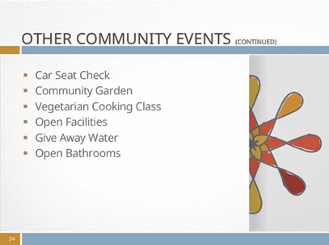 |  | Complimentary car seat check: According to new research published in the September 2012 issue of the American Journal of Preventive Medicine, only a small percentage of children in the U.S. are using age-appropriate safety restraints while riding in cars, and many children are seated in the front seat and are thus exposed to increased risk of injury in a crash.  Offer to host an event during which parents can bring their vehicle in and have their infant/children’s car seat inspected for safety. Ask an expert to thoroughly check each car seat to verify that it meets safety standards and it is age/height/weight appropriate for the child who will use it.  Community Garden: If there’s an unclaimed lot or unused space in the neighborhood, ask the community leaders to allow the Life Hope Center to plant a garden there. Once permission I given, clean out any debris on the lot and prepare the soil for planting. Invite the community to bring seeds and plant a section for their family’s personal use or to sell to raise funds for the Life Hope Center.  Once seeds or small plants have been planted, set up a schedule to determine who weeds, who waters, and who harvests the crops. Donate produce to local food banks and share the rest with those who worked on the garden.  Use the garden to encourage others to care for the earth and to help others. Or just have fun and invite individuals to plant what they love and harvest what they’ve tended.  Vegetarian cooking class: Offer a one-time vegetarian cooking class, perhaps as an introduction to a healthful living seminar to be held a few weeks later. Invite good cooks to submit their favorite vegetarian recipes and set up a tasting station where visitors can taste test some of the best recipes. Have brochures on hand to give each visitor, inviting them to an upcoming health lecture or seminar.  Open facilities to community organizations: There are many non-profit organizations, such as Alcoholics Anonymous, local drama groups, or aid-assistance groups such as Red Cross that need space to hold meetings during the week. Offer appropriate organizations use of Life Hope Center space without charge to help build community ties.  Give away water: Volunteer to supply water to runners during a race or to participants at a patriotic or festive event such as a parade. If you wish, print paper bottle wraps that tell recipients, “Compliments of the Life Hope Center” and give the address or web address. If you plan to provide water in cups, look into having cups printed with the Life Hope Center’s name and website address on them.  Open bathrooms: If your Life Hope Center is located near a local farmers’ market or parade route, consider opening your doors for the venders and customers. Such a service would help build goodwill with community organizers and visitors alike.
 | slide 35
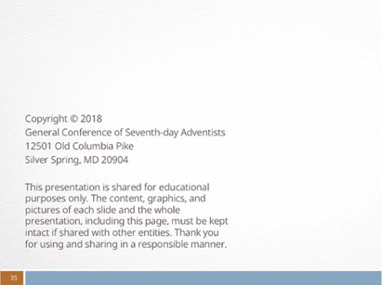 |  | Credits

Appendix: hearing test screening form

Do you have a problem hearing on the telephone or cell phone?
Yes □ No □

Do you have trouble hearing when there is noise in the background?
Yes □ No □

Is it hard for you to follow a conversation when two or more people talk at the same time?
Yes □ No □

Do you have to strain to hear and understand a conversation?
Yes □ No □

Do many people you talk to seem to mumble (or not speak clearly)?
Yes □ No □

Do you misunderstand what others are saying and respond inappropriately?
Yes □ No □

Do you often ask people to repeat themselves?
Yes □ No □

Do people complain that you turn the TV or radio volume up too high?
Yes □ No □

Source: U.S. Department of Health and Service. National Institute of Health helping the community

